**Design & Technology**

**Influence on design of anthropometrics an ergonomics**

**Materials required for questions**

* Pencil
* Rubber
* Calculator

**Instructions**

* Use black ink or ball-point pen
* Try answer all questions
* Use the space provided to answer questions
* Calculators can be used if necessary
* For the multiple choice questions, circle your answer

**Advice**

* Marks for each question are in brackets
* Read each question fully
* Try to answer every question
* Don’t spend too much time on one question

**Good luck!**

**Q1.** Ergonomics is the name given to the relationship between a product and its?

**A** Manufacture

**B** User

**C** Packaging

**Q2.** Which word is used to describe designing products well so they are easy to use?

**A** Aesthetics

**B** Usability

**C** Function

**Q3.** What is ergonomics?

**A** measurements of the human body

**B** data of human height

**C** The use of anthropometric data

**Q4.** What percentiles should designers design products for?

**A** 5th to 95th percentile

**B** 5th to 50th percentile

**C** 50th to 95th percentile

**Q5.** What might happen if ergonomics is not used in design?

**A** Users will have a poor user experience

**B** users might take offence

**C** users won’t be able to adapt the user

experience

**Q6.** Which of these is NOT an inclusive design factor?

**A** function

**B** cost

**C** material choice

**Q7.** The image below shows a remote control.

Give 3 ergonomic features in the design of the remote control **(3 marks)**

1.

2.

3.

**Q8.** The image below shows a games controller. Anthropometric data has been used to design the controller.

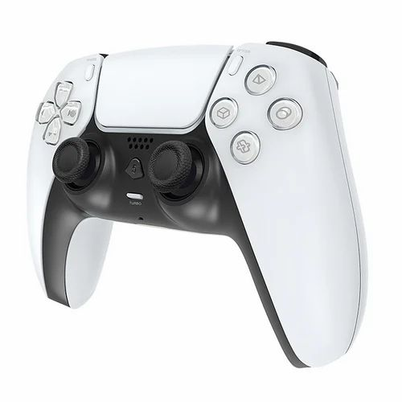

Name two official sources of anthropometric data **(2 marks)**

1.

2.

**Q9.** The image below shows some garden equipment. Outline features of the equipment that have been influenced by anthropometrics **(5 marks)**

**Answers**

**Q1. B  
Q2. B  
Q3. C  
Q4. A  
Q5. A  
Q6. B**

**Q7.**

Award 1 mark for each ergonomic feature up to a maximum of 3:

* buttons easy to see
* comfortable or rounded shape in hand
* appropriate size to fit hand
* colour-coded buttons for ease of operation
* rubber buttons for better selection

**Q8.**

* British Standards Institute (BSI) (1)
* Department of Business Innovation and Skills (BIS) (1) (also accept Department for Trade and Industry (DTI))
* Compendium of essential design and technology standards for schools and colleges (1)
* European (anthropometric) database (1)
* European sizing survey (1)
* International Standards Organisation (ISO) (1)
* World Health Organisation (WHO) (1)

**Q9.**

* Length of hand/fingers have influenced the diameter of the hand holds. (1)
* Finger sizes have influenced the size/length/width of the trigger switch. (1)
* Range of finger movement has influenced how far the trigger switch moves. (1)
* Position of fingers / stronger fingers have influenced the position of the trigger. (1)
* Arm reach has influenced the distance between the two handles (1)
* Range of comfortable wrist movement has influenced the angle if the top handle. (1)
* Width / thickness of fingers have influenced the guard gap in the handle. (1)
* The width of a human hand has influenced the position of the two hand hold positions (1)